**Physiology 115 Name ______________________________**Spring 2015

**QUIZ #3**

For the multiple choice questions, there is *one* and *only one* best answer. Use the back of the sheet if you need to complete answers.

1. Which mode of bulk transport does the cell use to import LDL (to get cholesterol generally)?
   1. receptor-mediated exocytosis
   2. **receptor-mediated endocytosis**
   3. exocytosis
   4. phagocytosis
   5. pinocytosis
2. How many high-energy phosphate bonds does ATP have that can be used in metabolism?
   1. zero
   2. one
   3. **two**
   4. three
   5. four
3. A vesicle that fuses with a membrane and expels its contents out of the cell depends on which of these processes?
   1. formation of pseudopodia
   2. protons (H+) being pumped into the vesicle
   3. clathrin encircling the vesicle
   4. **calcium (Ca2+) entering the cytosol**
   5. all of the above
4. (a) show the reaction of the pyruvate dehydrogenase enzyme: the substrate, the products, the electron-accepting cofactor and what it forms after the reaction, and the cofactor that forms a high energy bond with one of the products [there should be six elements in your reaction with the arrow, showing what goes in and what comes out, with perhaps curved arrows drawn as well]  
   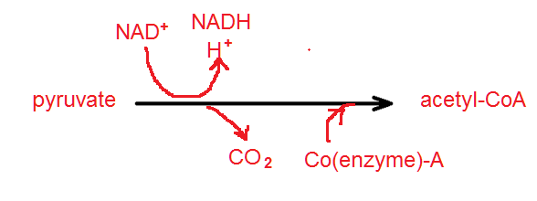  
   (b) what is the name of the important metabolic pathway its product feeds into in the mitochondria?  
     
   Tricarboxylic acid (TCA) cycle or Krebs cycle